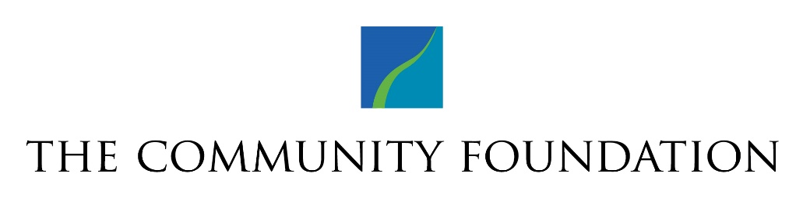
ESTABLISHMENT OF A DONOR ADVISED CHARITABLE INVESTOR FUNDSM
This DONOR ADVISED FUND AGREEMENT ("Agreement") is made on Click or tap here to enter text. (date), between Rochester Area Community Foundation, a charitable community foundation ("Foundation"), and Click or tap here to enter text. (“Donor(s)”) to create a Charitable Investor Fund ("Fund") of the Foundation.
- Name of Fund. The name of the Fund created hereby is the Click or tap here to enter text. Fund.

2) Initial Contribution. Upon signing this Agreement, the Donors will transfer and deliver to the
Foundation the property described as follows: Click or tap here to enter text.

3) Purpose. The Fund will further the charitable and educational purposes of the Foundation.
4) Successor Advisor(s). After the donor’s(s’) lifetime(s) the balance of the fund will be endowed and the
following person(s) is (are) authorized to recommend grants:

Name 1: Click or tap here to enter text. | Name 3: Click or tap here to enter text.
Name 2: Click or tap here to enter text. | Name 4: Click or tap here to enter text.

After the successors’ lifetimes, remaining balances over $25,000 will benefit the community by being:

☐ maintained in the name of the fund as a permanent endowment for general community purposes.
☐ maintained in the name of the fund as a permanent fund for the following field(s) of interest:
Click or tap here to enter text.
5) Management. The Foundation hereby agrees to accept cash and other valuable property transferred to it by the donors who wish to participate in the Fund. Gifts to the Fund shall be invested as part of the Foundation's Charitable Investor funds, subject to the same investment guidelines and policies as apply to other funds in this program. Any fundraising activity must be approved by the Community Foundation in advance. The Fund is open ended and may be added to at any time. The fund’s initial asset allocation should be: Click or tap here to enter text. (options: 85/0/10/5%, 70/15/10/5%, 50/35/10/5%, 30/55/10/5%, 0/85/10/5%, 0/0/0/100% equity/fixed/alternatives/cash split).

6) Distributions. Distributions from the Fund shall be made in accordance with such procedures for the administration and operation of such funds of the Foundation as may be in effect from time to time. The Foundation hereby agrees to receive recommendations regarding distributions for charitable uses. Distributions from the Fund shall be made in the name of the Fund. The minimum distribution is $250. If the fund has remained dormant without grantmaking for three years, the Foundation will make every effort to secure grantmaking advice from the advisor(s) and, if unsuccessful, will make distributions in accordance with Board-designated priorities for this region.

7) Compensation to the Foundation. As compensation for its services the Foundation shall receive those fees which it customarily charges for services of a nature similar to those required (currently 1% of assets or $250 minimum per annum).

8) Variance Power. The Fund is protected from obsolescence. Should the purposes for which the Fund is established ever become obsolete, unnecessary, incapable of fulfillment, or inconsistent with the charitable needs of the community, the Board of Directors of the Foundation shall in its sole judgment select a similar use for the funds that will most nearly fulfill the original charitable intent of the Fund.
The Foundation represents that it is a not-for-profit tax-exempt organization authorized to establish the Fund, that it has a 501(c)(3) tax exempt designation from the Internal Revenue Service, and that contributions to the Fund will be tax deductible by the donors. Any statement in this Agreement notwithstanding, contributions to the Fund, like all contributions to the Foundation, are funds of the Foundation and must be administered in accordance with its charter and bylaws and in accordance with applicable laws and regulations governing the Foundation.

Donor(s) signature and date |  | Rochester Area Community Foundation
Donor #1: |  | Signature:
Donor #2: |  | Title: | Click or tap here to enter text.
Date: | Click or tap to enter a date. | Date: | Click or tap to enter a date.

