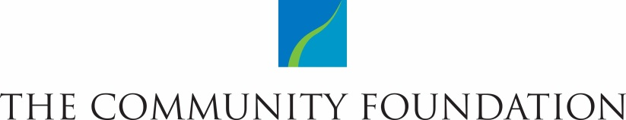

Demographic Survey of Community Foundation Grant Applicants

Rochester Area Community Foundation is committed to creating a more equitable, vibrant region and encourages applicant organizations to partner with us in this endeavor by reflecting on their commitment to promoting equity within their organizations.
Our application includes a request for the demographics of applicants’ boards and staff. This information will not be used to determine grant awards. Rather, it will be used to provide a snapshot of the diversity within community organizations that have applied for and/or received Community Foundation funding.
Please complete this document and submit it with your application.

Organization Name: Date:
Please enter a number or Unk (unknown) in each cell* | Gender |  |  | Race & Ethnicity |  |  |  |  | Other Characteristics
 | Male | Female | Identify otherwise | White/  Caucasian | Black/  African American | Latino/ Hispanic  (of any race) | Asian American/ Pacific Islander or Asian Indian | Native American/ Alaska Native | LGBT | Foreign-born (Immigrant) | Disability
Board
Managerial/Supervisory Staff
Other Staff
Please note: The Census Bureau collects gender/race data in accordance with guidelines provided by the U.S. Office of Management and Budget. These demographic categories are based on that self-identification.
*We recognize that some organizations may not yet collect all of this information. In that case, please enter Unk (unknown) where needed.

