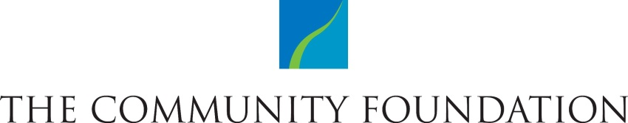

ESTABLISHMENT OF A
FIELD OF INTEREST ENDOWMENT FUND

This FIELD OF INTEREST ENDOWMENT FUND AGREEMENT ("Agreement") is made this day of , , between Rochester Area Community Foundation, a charitable community foundation ("Foundation"), and ("Donor") to create an endowment fund
("Fund") of the Foundation.

- Name of Fund. The name of the Fund created hereby is the

- Initial Contribution. Upon signing this Agreement, the Donor will transfer and deliver to the Foundation the property described as follows:

- Purposes. The purposes of the Fund are to further or carry out the charitable and educational purposes of the Foundation by

- Management. The Foundation hereby agrees to accept cash and other valuable property transferred to it by the Donor and others who wish to participate in the Fund. Gifts to the Fund shall be invested and reinvested as part of the Foundation's permanent endowment funds, subject to the same policies for investment, determination of current distribution amount, and allocation to cover Foundation administrative costs, as shall be adopted from time to time for its permanent endowment funds. Any fundraising activity must be approved by the Community Foundation in advance. The Fund is open ended and can be added to at any time.
- Distributions. Distributions from the Fund shall be made in accordance with such procedures for the administration and operation of such funds of the Foundation as may be in effect from time to time. Distributions from the fund shall be made in the name of the Fund.
- Compensation to Foundation. As compensation for its services the Foundation shall receive those annual fees which it customarily charges for services of a nature similar to those required herein (currently 1.25% of principal with a minimum of $250 per annum). Additional fees may be applied at higher levels of service.
- Variance Power. The Fund is protected from obsolescence. Should the purposes for which the Fund is established ever become obsolete, unnecessary, incapable of fulfillment, or inconsistent with the charitable needs of the community, the Board of Directors of the Foundation shall in its sole judgment select a similar use for the funds which will most nearly fulfill the original charitable intent of the Donor.
The Foundation represents that it is a not-for-profit tax-exempt organization authorized to establish the Fund, that it has a 501(c)(3) tax exempt designation from the Internal Revenue Service, and that contributions to the Fund will be tax deductible by the donors. Any statement in this Agreement notwithstanding, contributions to the Fund, like all endowment contributions to the Foundation, are permanent funds of the Foundation and must be administered in accordance with its charter and bylaws and in accordance with applicable laws and regulations governing the Foundation.

DONOR |  | ROCHESTER AREA COMMUNITY FOUNDATION
Sign |  | Sign
Print |  | Title
Date |  | Date

